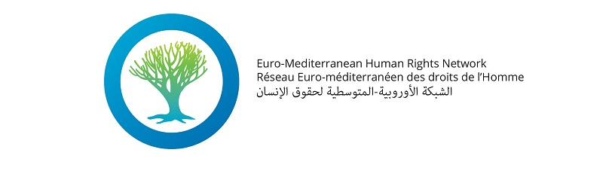

TAKE ACTION!

- EMHRN invites you to take a further, more active step towards EU Member State Governments by writing to your Head of State/Government and Ministers of Foreign Affairs and Interior. Contact details can be found through the website of your national Minister of Foreign Affairs.
You will find below a model letter that you can use for that purpose. If you send your letters by email, EMHRN would appreciate if you could copy us in order to ease the monitoring of the action, using the following address: EMHRN.BE@euromedrights.net

Model letter

Dear (Name/Function),

I write to you to express my deep concerns about the fact the extraordinary European Summit of 23 April adopted Council’s conclusions that fall far short - both politically and morally - of the humanitarian challenges posed by the repetitive tragedies in the Mediterranean sea. In the face of such tragedies, the EU should reinforce existing search-and-rescue mechanisms across all the Mediterranean to save more lives, rather than tightening border controls.

I’m shocked by the death toll at sea, which has risen to 1,800 this year alone. By framing a humanitarian pressing issue in security terms and refusing to offer legal safe channels to migrants and refugees, the EU evades its responsibility toward its plagued neighbours and woefully leaves men, women and children perish in the sea.

At domestic and European level, I exhort you to:
- Urgently prioritise search and rescue tasks over surveillance, and provide both financial and technical support to competent Search and Rescue (SAR) mechanisms;
- Open legal and secure channels to all migrants, and ensure that refugees have access to the European territory where their individual situation can be assessed;
- Immediately address resettlement needs of refugees fleeing conflicts in the South and East Mediterranean region, particularly as regards the Syrian crisis, as well as in sub-Saharan Africa;
- Stop conditioning access to mobility to the EU for non-EU nationals upon the signature of readmission agreements by their country of origin, and stop using external cooperation as a means to reinforce border controls.

Yours sincerely,

